**TUGAS PENDAHULUAN**

**PRAKTIKUM 8**

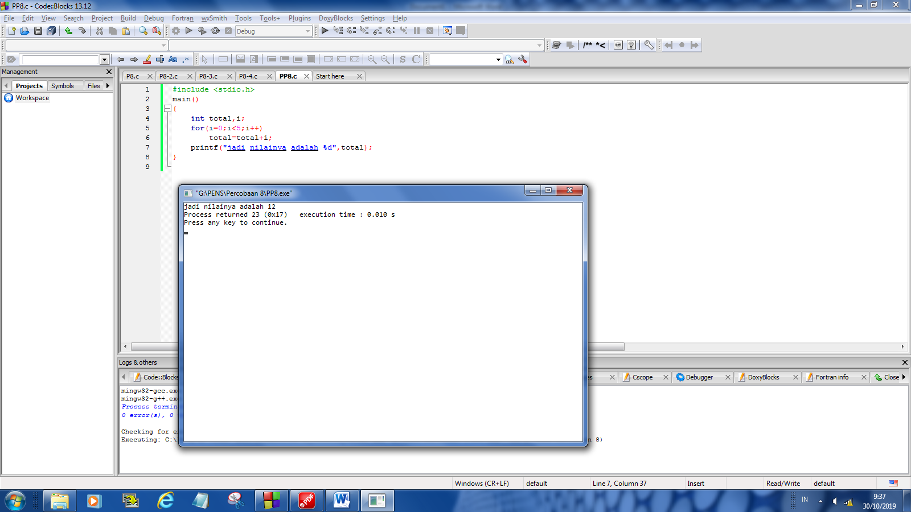

#include <stdio.h>

main()

{

int total,i;

for(i=0;i<5;i++)

total=total+i;

printf("jadi nilainya adalah %d",total);

}

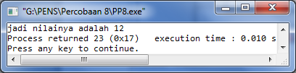

**LAPORAN PERCOBAAN**

**PRAKTIKUM 8**

**Percobaan 1 (a) :**

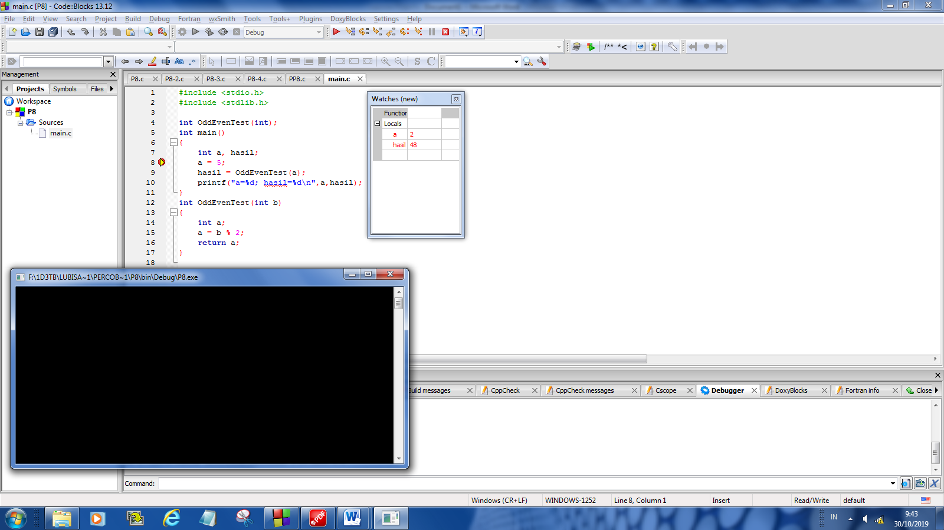 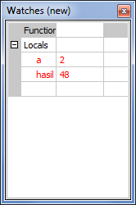

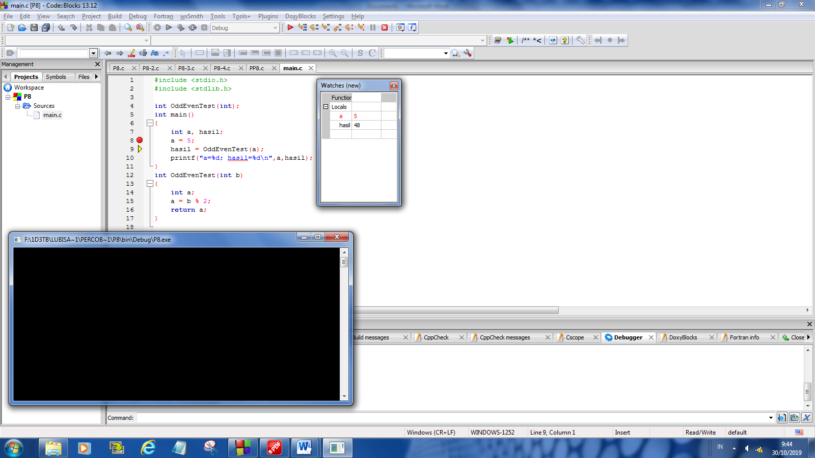 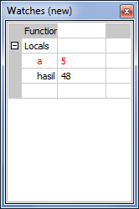

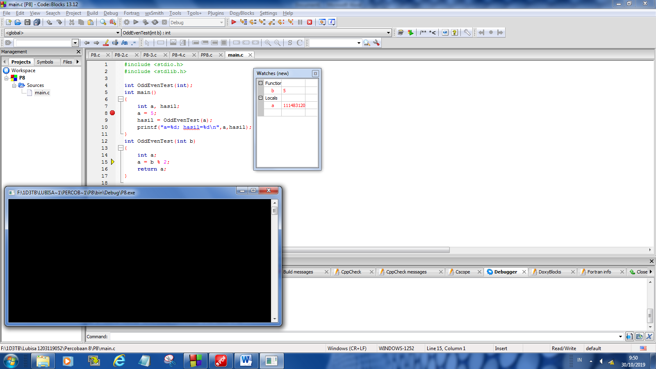 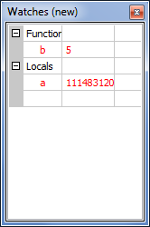

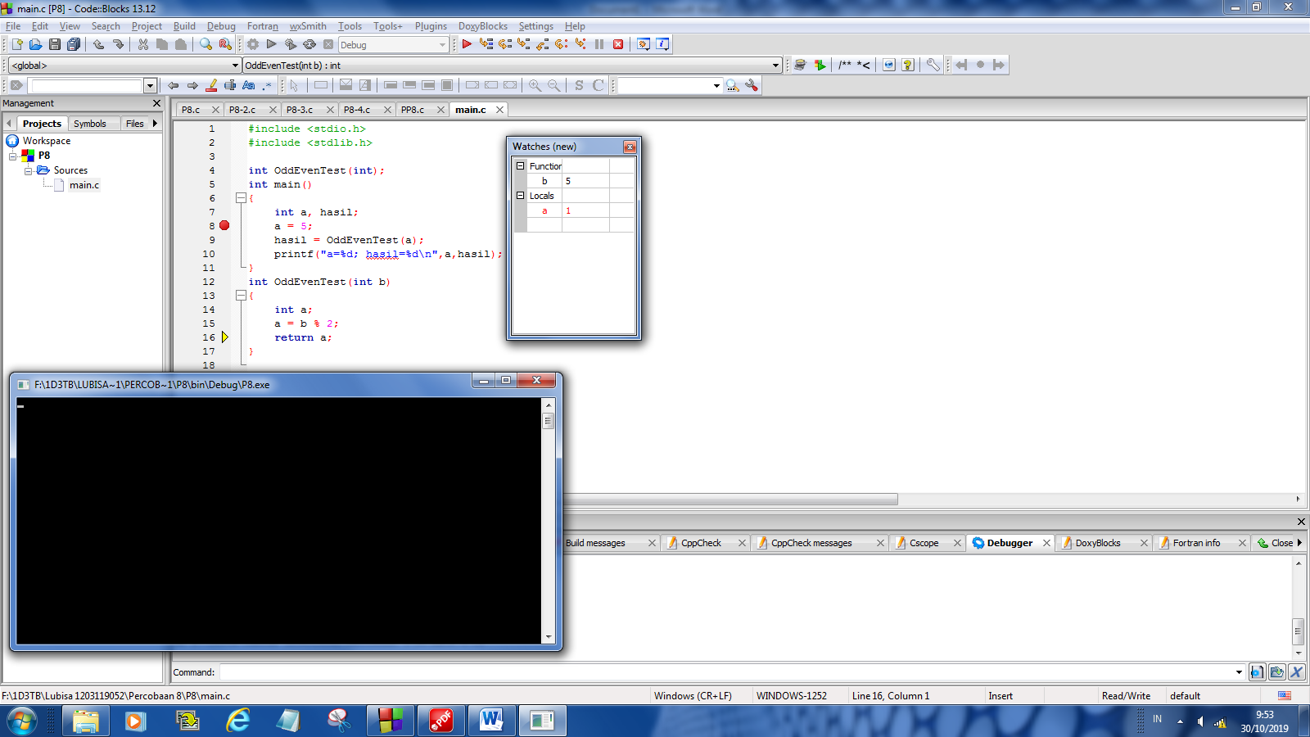 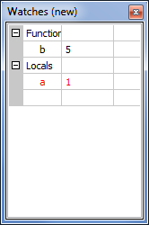

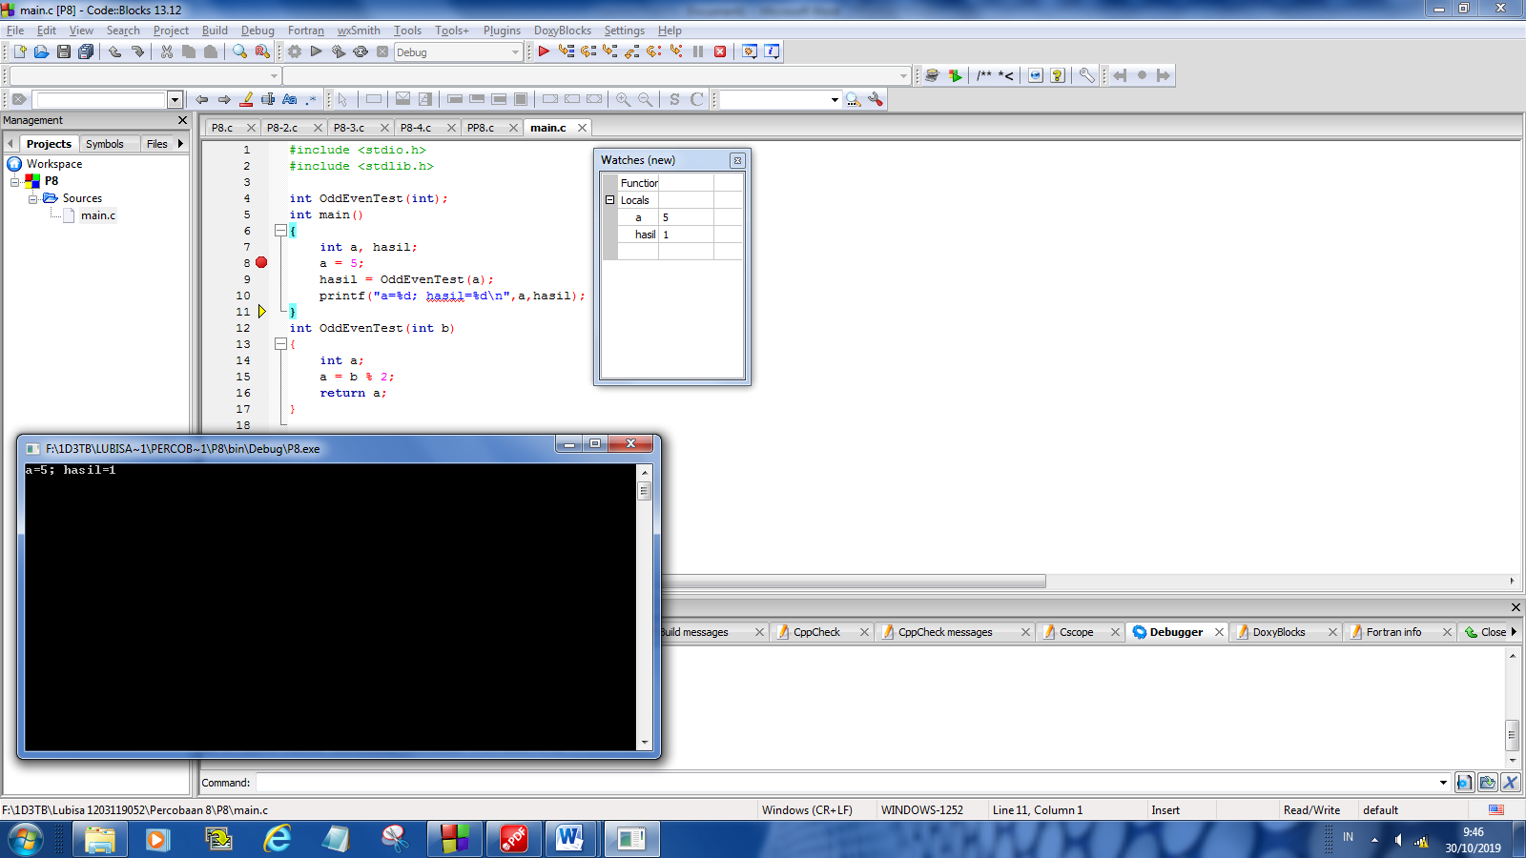 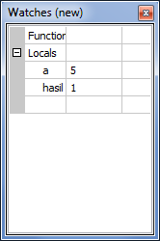



#include <stdio.h>

#include <stdlib.h>

int OddEvenTest(int);

int main()

{

int a, hasil;

a = 5;

hasil = OddEvenTest(a);

printf("a=%d; hasil=%d\n",a,hasil);

}

int OddEvenTest(int b)

{

int a;

a = b % 2;

return a;

}

**Percobaan 1 (b) :**

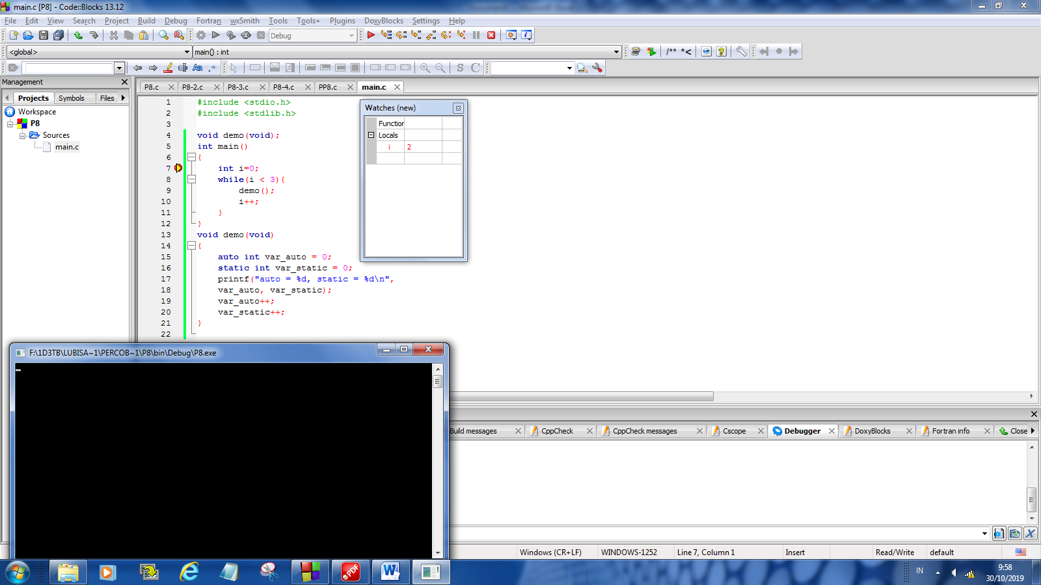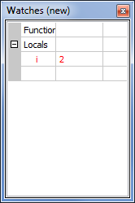

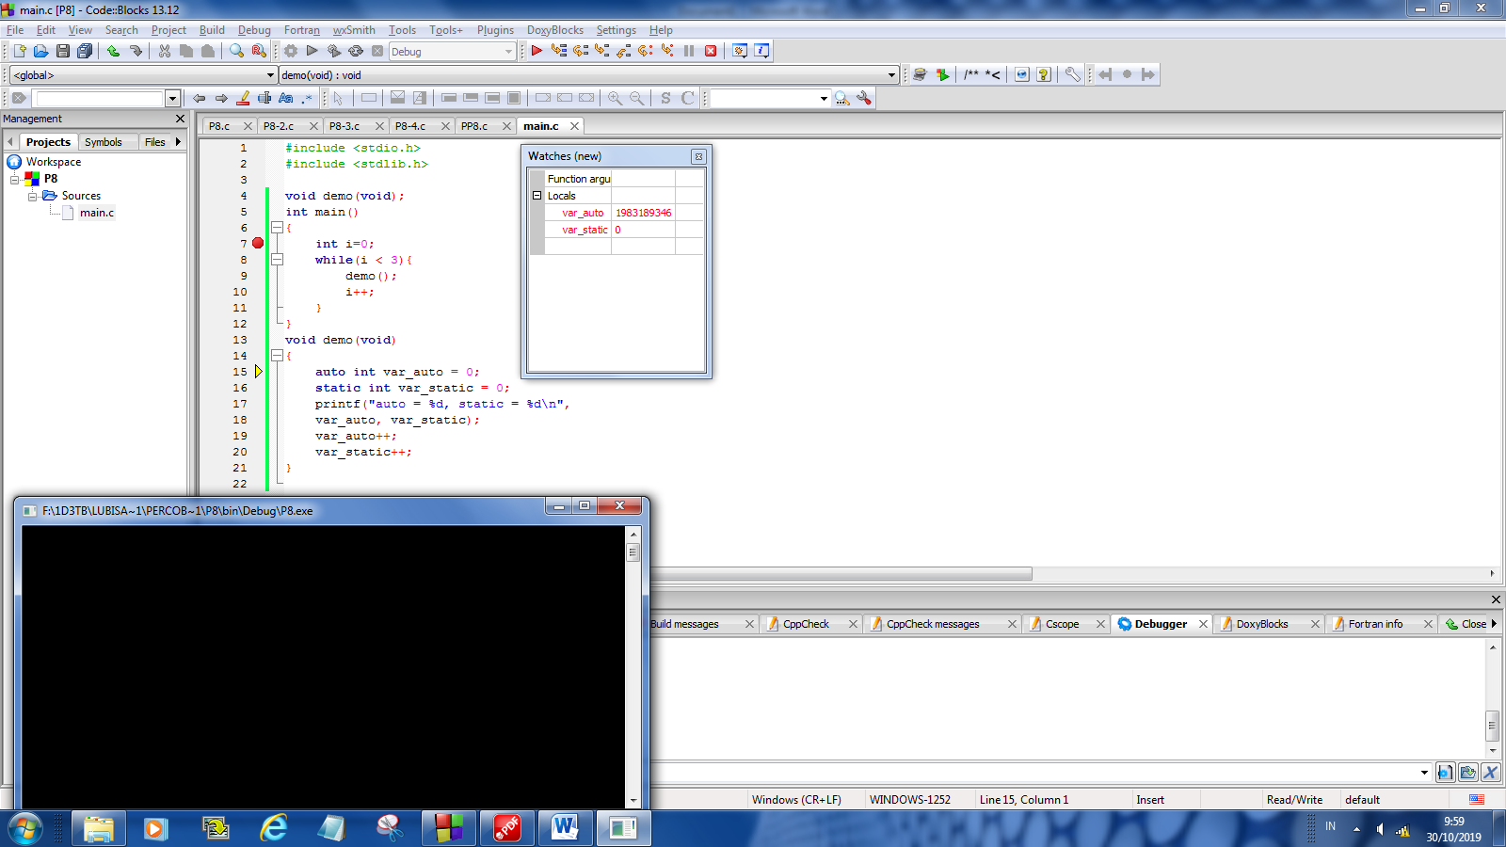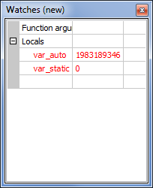

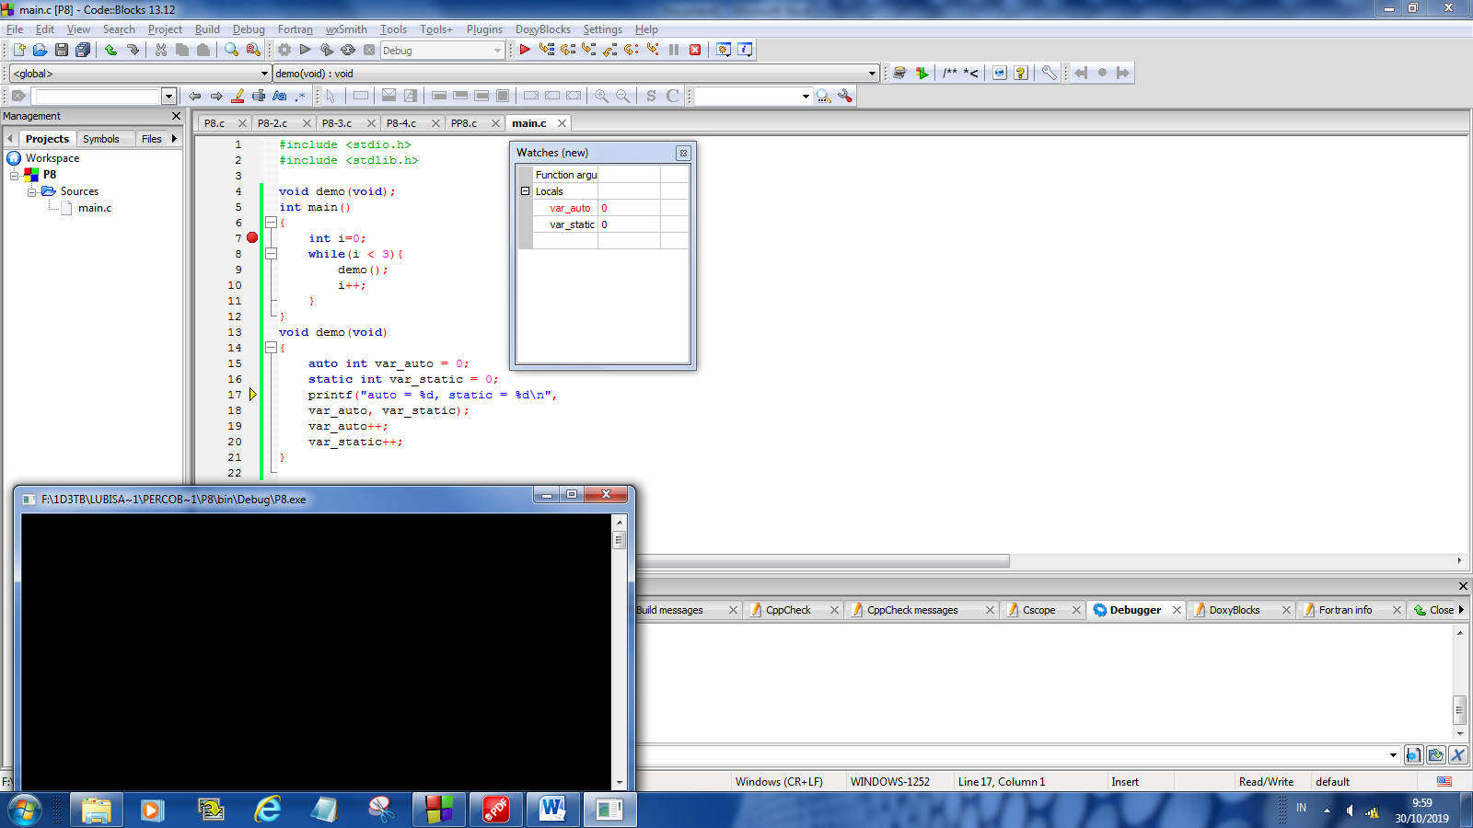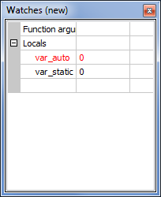

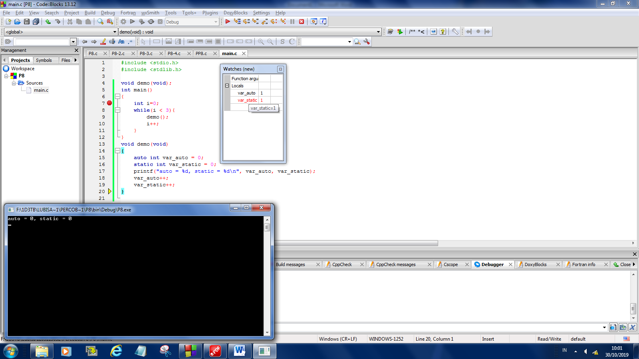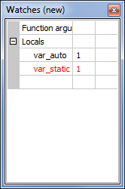



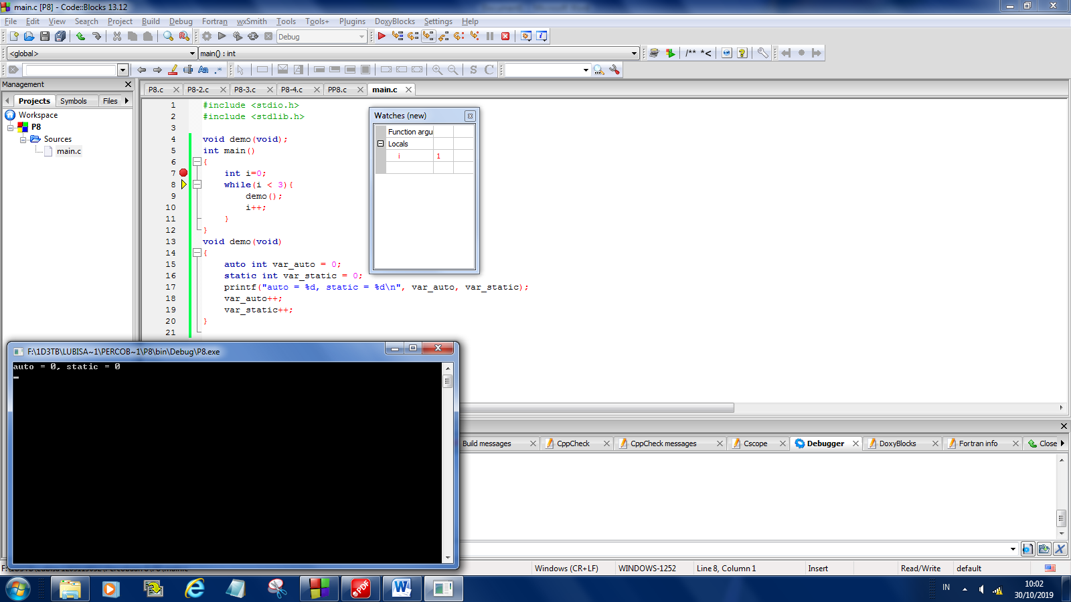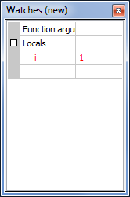

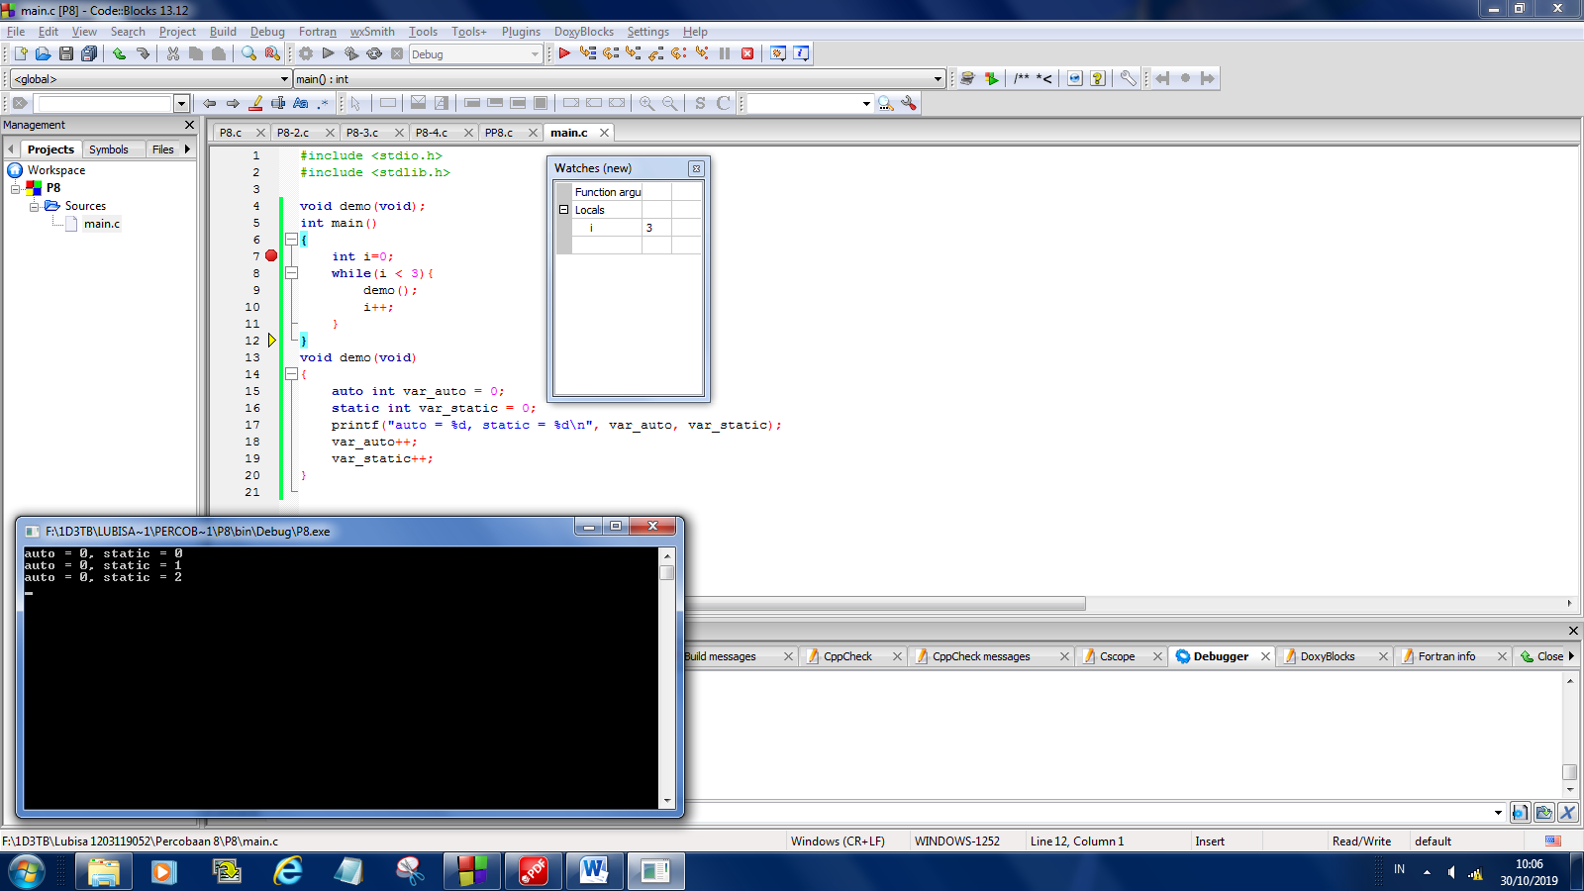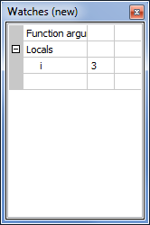

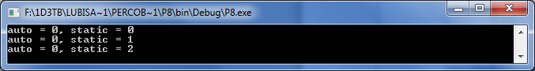

#include <stdio.h>

#include <stdlib.h>

void demo(void);

int main()

{

int i=0;

while(i < 3){

demo();

i++;

}

}

void demo(void)

{

auto int var_auto = 0;

static int var_static = 0;

printf("auto = %d, static = %d\n", var_auto, var_static);

var_auto++;

var_static++;

}

**Percobaan 1 (c) :**

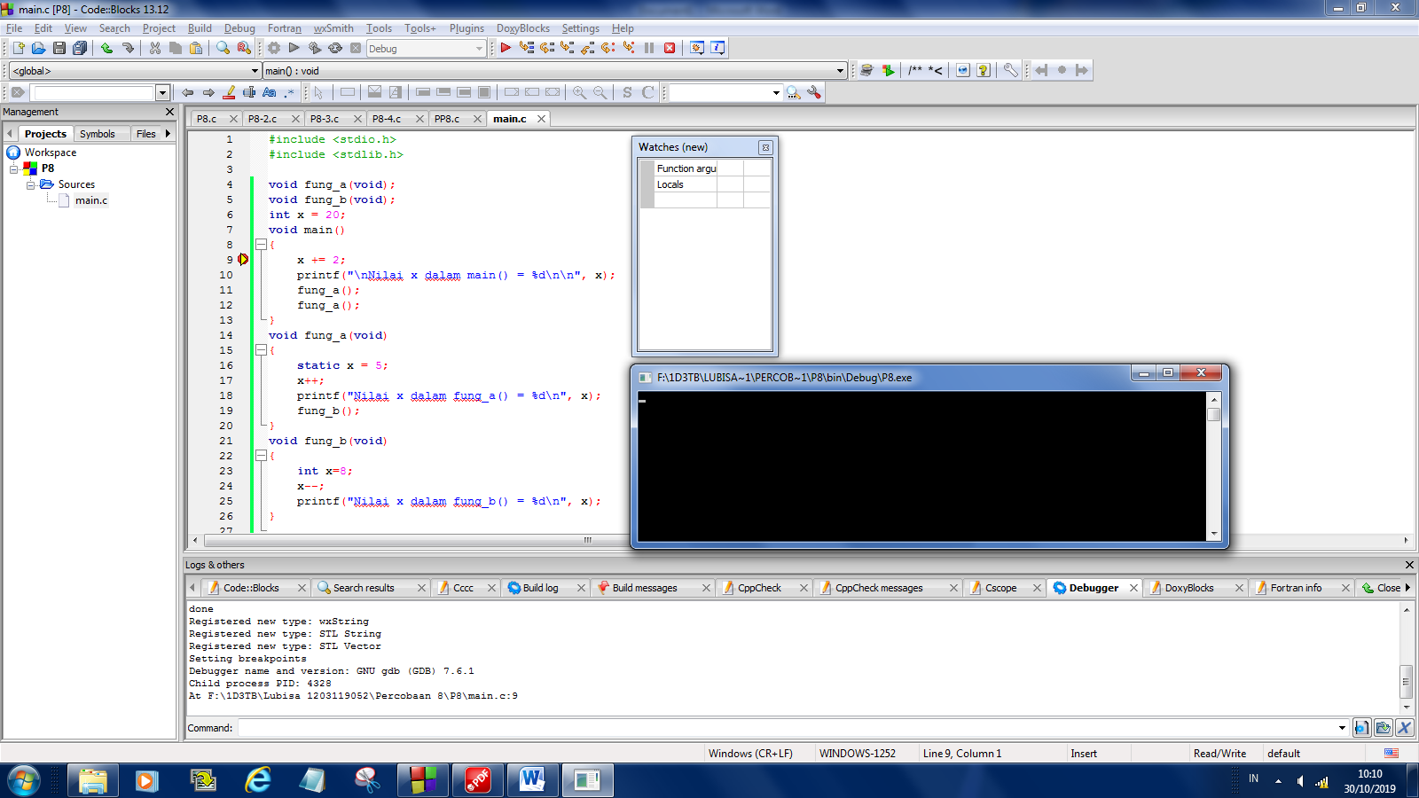 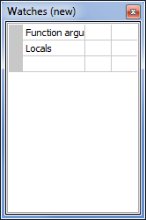

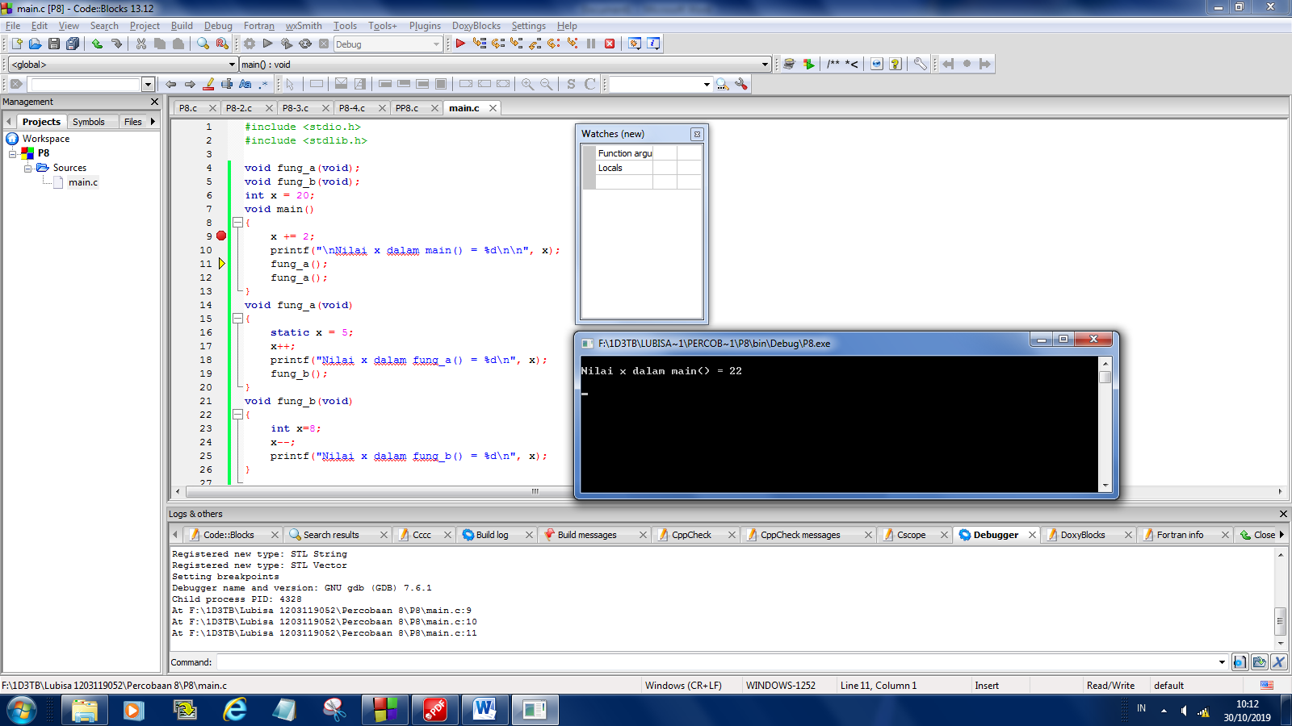 

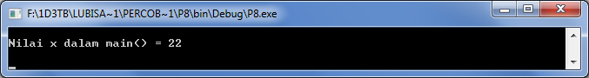

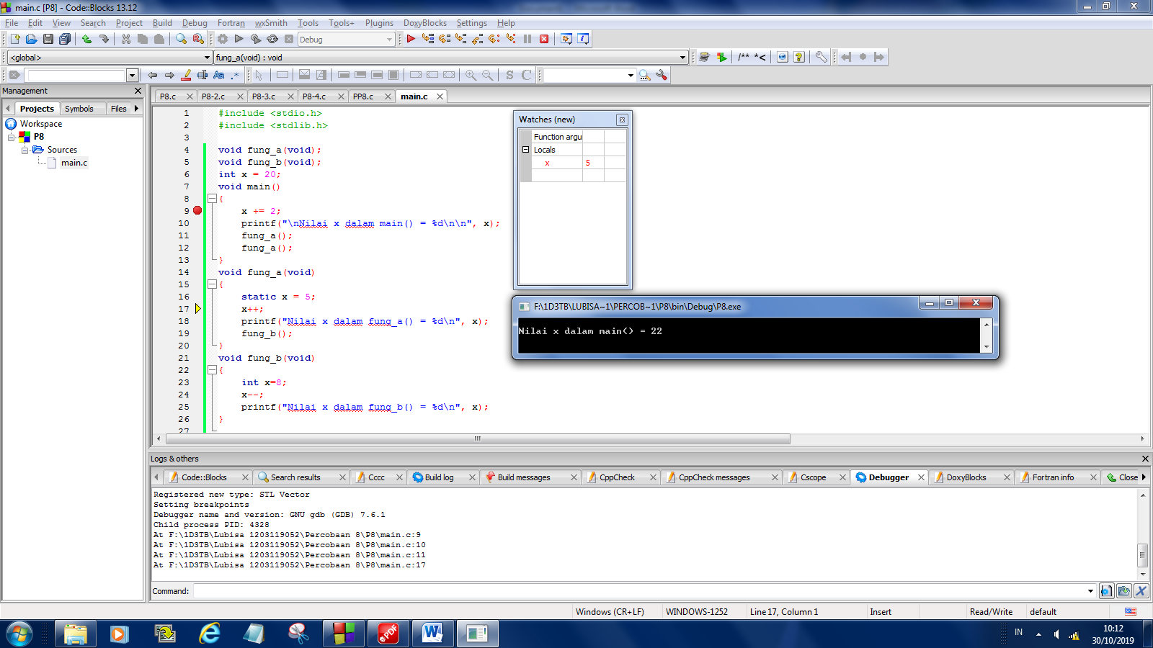 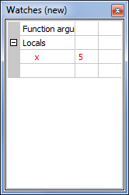

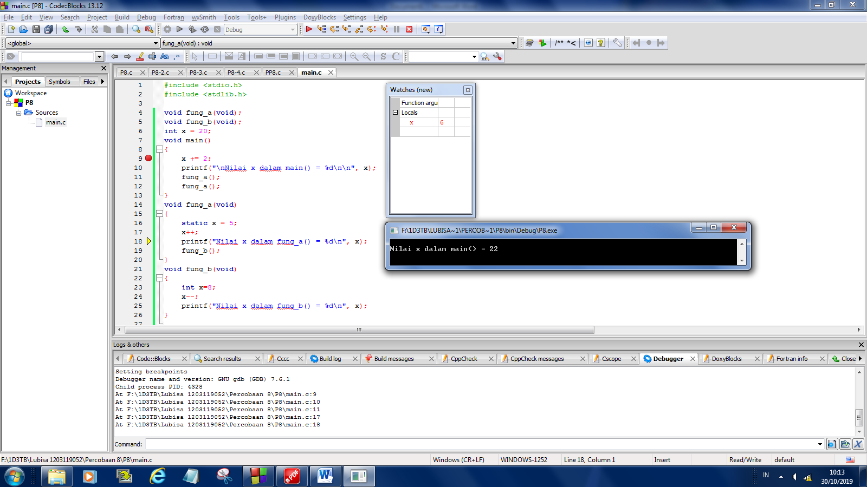 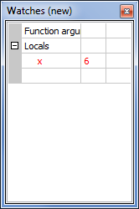

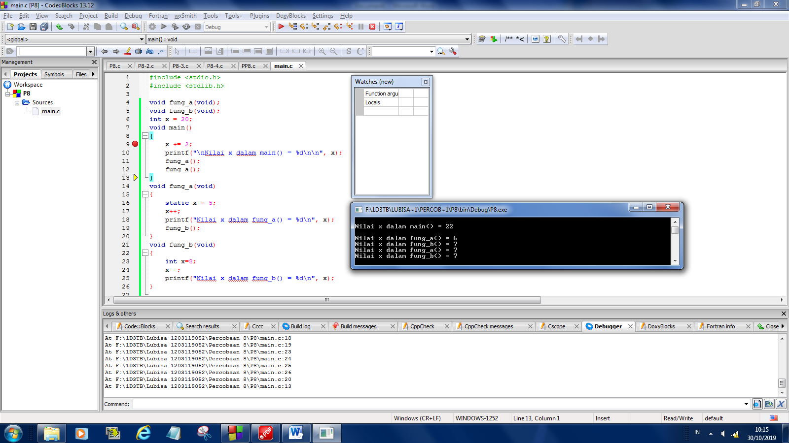 

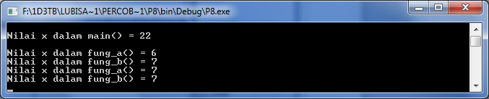

#include <stdio.h>

#include <stdlib.h>

void fung_a(void);

void fung_b(void);

int x = 20;

void main()

{

x += 2;

printf("\nNilai x dalam main() = %d\n\n", x);

fung_a();

fung_a();

}

void fung_a(void)

{

static x = 5;

x++;

printf("Nilai x dalam fung_a() = %d\n", x);

fung_b();

}

void fung_b(void)

{

int x=8;

x--;

printf("Nilai x dalam fung_b() = %d\n", x);

}

**PERCOBAAN 2**

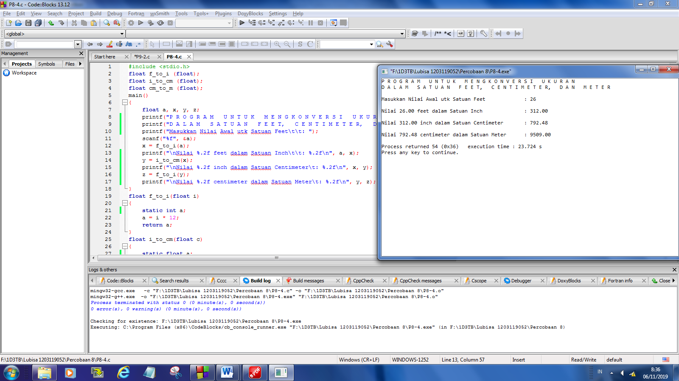

#include <stdio.h>

float f_to_i (float);

float i_to_cm (float);

float cm_to_m (float);

main()

{

float a, x, y, z;

printf("P R O G R A M U N T U K M E N G K O N V E R S I U K U R A N\n");

printf("D A L A M S A T U A N F E E T, C E N T I M E T E R, D A N M E T E R\n\n");

printf("Masukkan Nilai Awal utk Satuan Feet\t\t: ");

scanf("%f", &a);

x = f_to_i(a);

printf("\nNilai %.2f feet dalam Satuan Inch\t\t: %.2f\n", a, x);

y = i_to_cm(x);

printf("\nNilai %.2f inch dalam Satuan Centimeter\t: %.2f\n", x, y);

z = f_to_i(y);

printf("\nNilai %.2f centimeter dalam Satuan Meter\t: %.2f\n", y, z);

}

float f_to_i(float i)

{

static int a;

a = i * 12;

return a;

}

float i_to_cm(float c)

{

static float a;

a = c * 2.54;

return a;

}

float cm_to_m(float m)

{

static float a;

a = m / 100;

return a;

}

